**PROJECT REPORT**

TOP 10 STARTUPS WITH MAXIMUM NUMBER OF INVESTORS

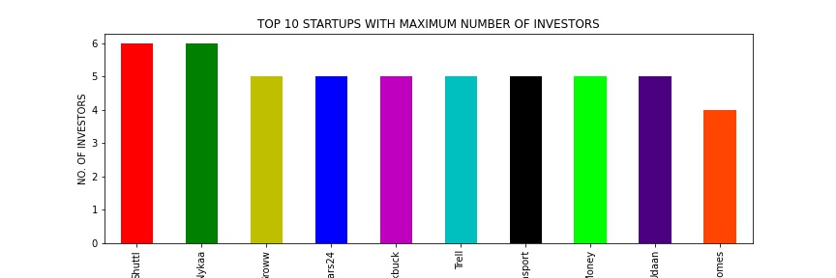

TOP 10 STARTUPS BASED ON THE AMOUNT OF INVESTMENT THEY GOT

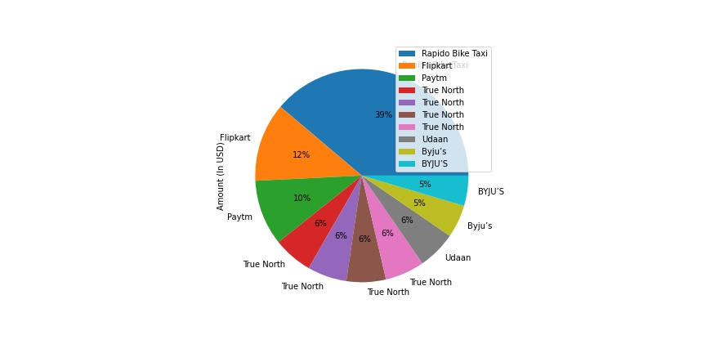

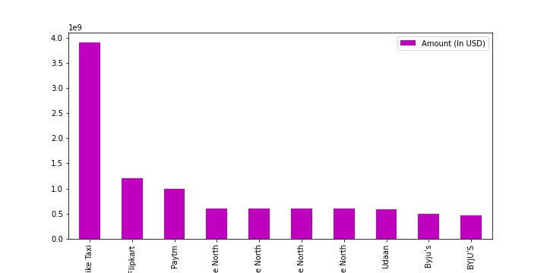

NO. OF UNIQUE INVESTORS = 332

Top 10 Investors in Indian ecosystem according to the total amount they invested in startups

|  | **index** | **Investors' Name** | **Amount (In USD)** |
| --- | --- | --- | --- |
| **0** | 322 | Westbridge Capital | 3.900000e+09 |
| **1** | 319 | Walmart Inc\n | 1.200000e+09 |
| **2** | 316 | Vijay Shekhar Sharma | 1.000000e+09 |
| **3** | 77 | DST Global and Lightspeed Venture Partners’ gl... | 9.000000e+08 |
| **4** | 127 | Innoven Capital | 7.100000e+08 |
| **5** | 148 | Lighthouse | 6.288000e+08 |
| **6** | 26 | Altimeter Capital, DST Global | 5.850000e+08 |
| **7** | 158 | MC Global Edtech, B Capital, Baron, others | 5.430000e+08 |
| **8** | 260 | SoftBank Vision Fund | 5.310000e+08 |
| **9** | 255 | Silver Lake, Tiger Global, General Atlantic an... | 5.000000e+08 |

Top 10 industries which are favourite of Investors

| **index** | **Industry / Vertical** |
| --- | --- |
| **0** | Consumer Internet | 148 |
| **1** | Technology | 47 |
| **2** | Finance | 36 |
| **3** | E-commerce | 31 |
| **4** | Healthcare | 30 |
| **5** | Fin-Tech | 24 |
| **6** | FinTech | 23 |
| **7** | IT | 16 |
| **8** | EduTech | 12 |
| **9** | E-Commerce | 12 |

Top 10 Sub-industries in Technology industry according to number of times Investors invested in Startups.

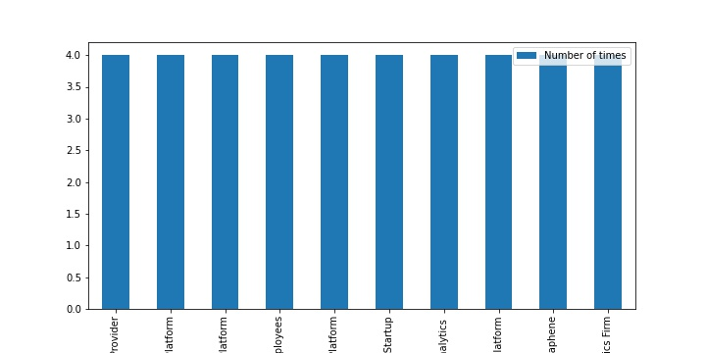

Top 10 cities which have maximum startups

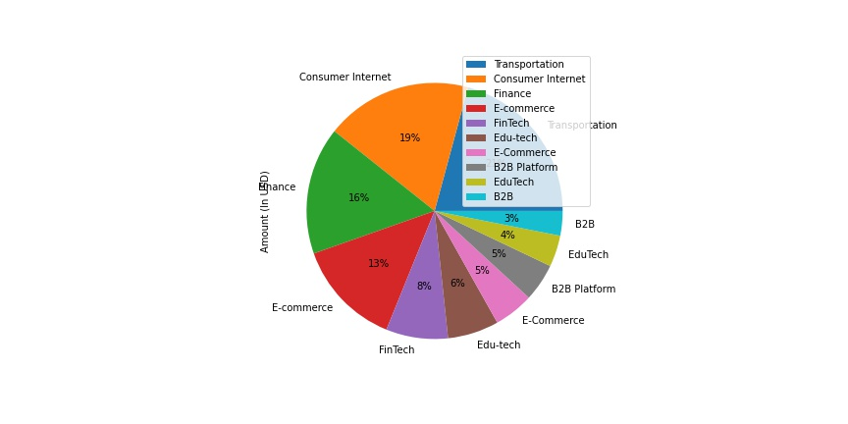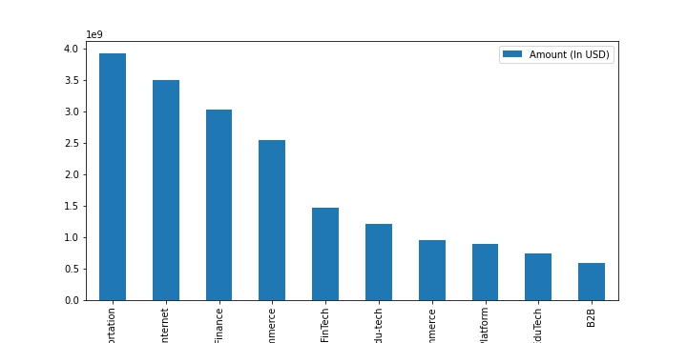

TYPE OF INVESTMENTS

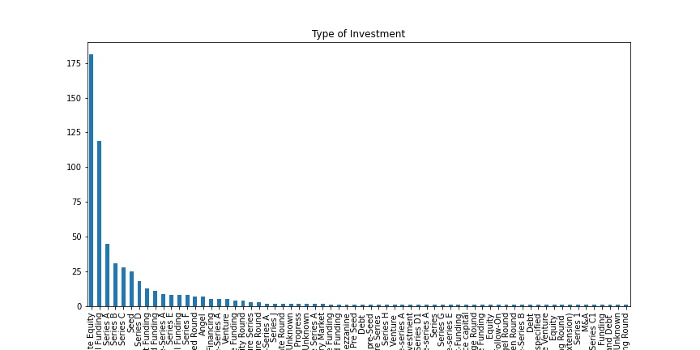

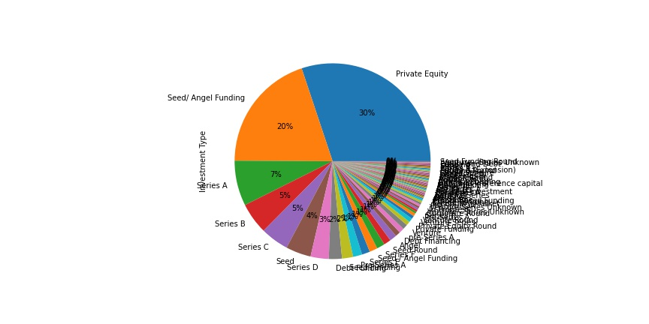

Distribution of Investments by City

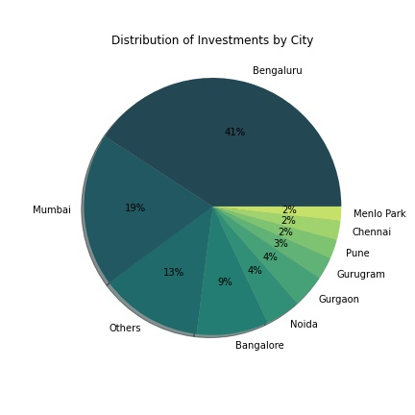

WORDCLOUD OF TECHNOLOGY INVESTORS

